Group 6: Assoc. Prof. Pelin Özener
Group 7: Asst. Prof. Dr. Nejat N. Çetinkaya

INS3121
December 26th, 2018

SOIL MECHANICS
MAKE UP EXAM
Q.1 | Q.2 | Q.3 | Q.4 | Q.5 | TOTAL
Name and Surname:
Number:
Group:

- Grain-size distribution curves of two type of soil are given in the below figure,
- Define whether of two soils are given is well-graded or poor-graded soil.
- Classify the soils according to Unified Soil Classification System (USCS) and American Association of State Highway and Transportation Officials (AASHTO) Classification System.
- Which one of the soil can be used as a subgrade material in a highway construction?
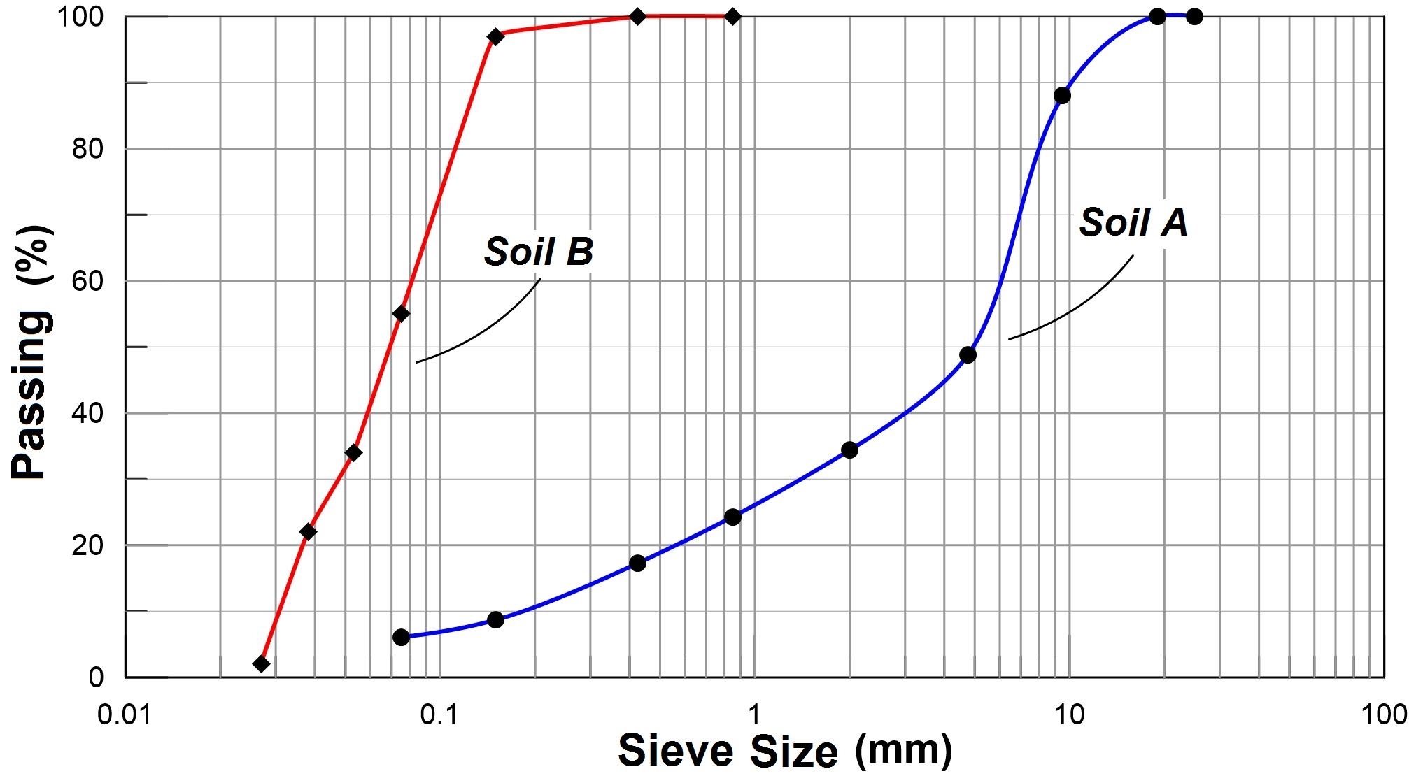
 | % Passing
Sieve No | Soil  A | Soil  B
4 | 48.8 | 100
10 | 34.4 | 100
20 | 24.3 | 100
40 | 17.3 | 100
100 | 8.7 | 97
200 | 6.1 | 55
LL (%) | 40 | 48
PL (%) | 30 | 27
- Given the soil profile below:
- Determine the total vertical pressures (σ), pore-water pressures (u), and effective vertical pressures (σꞌ) at points A, B, C, and D and draw the variations of the stresses with depth (Assume dry soil above GWT level).
- Calculate the vertical stress increase (Δσ) at the levels of C due to a mat foundation, which has a dimension of 15 m x 25 m and is uniformly loaded with a pressure of 120 kPa due to superstructure.

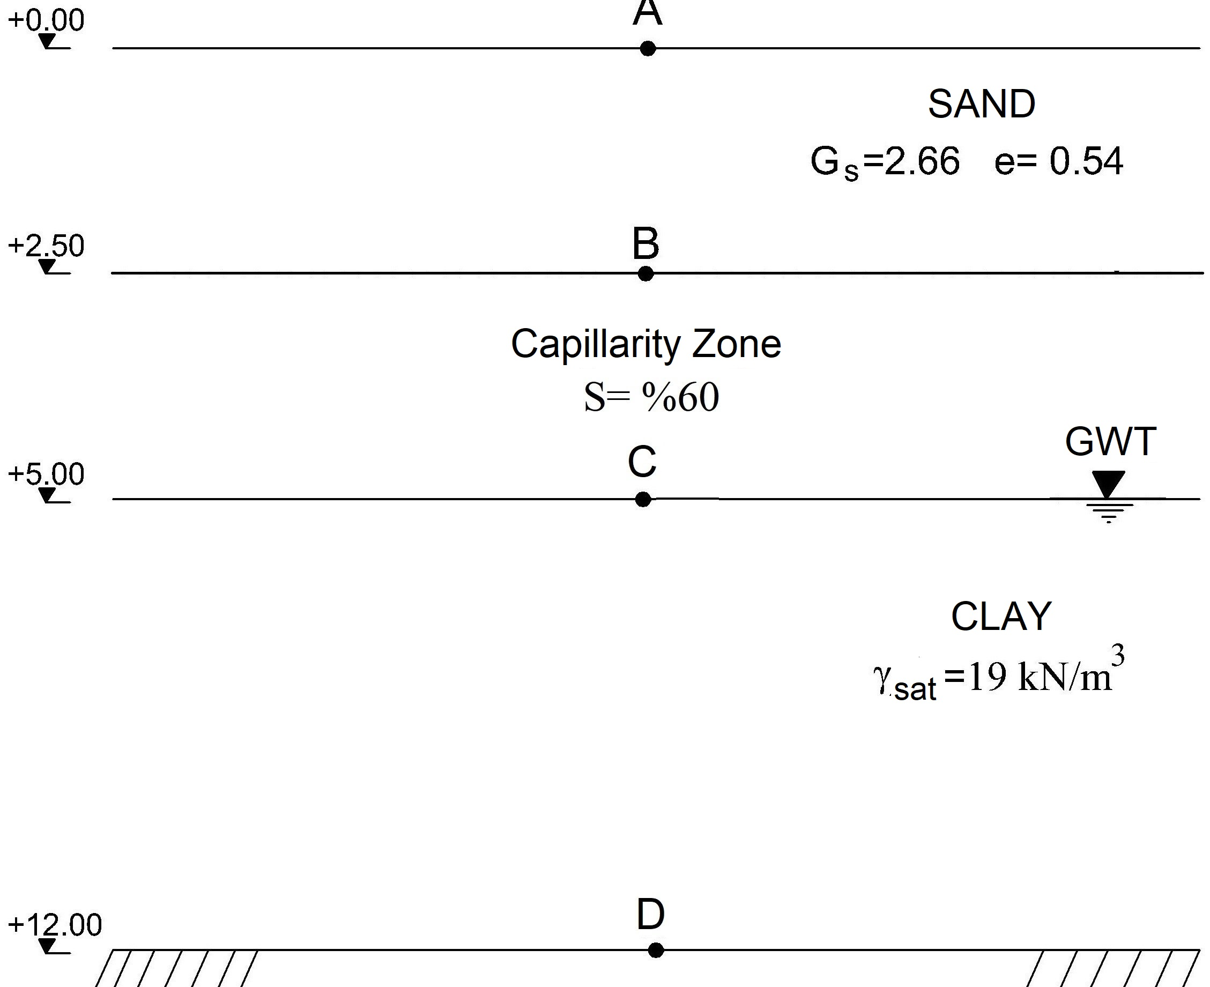

- The flow-net for the water seepage below a sheet pile wall is given below. The hydraulic conductivity (permeability) of the soil is determined to be k=4.8x10⁻⁶ cm/sec. According to the given information,

- Calculate the amount of water seepage under the sheet pile wall per unit length.
- Calculate the total hydraulic head and water pressure at points A, B, and, C.
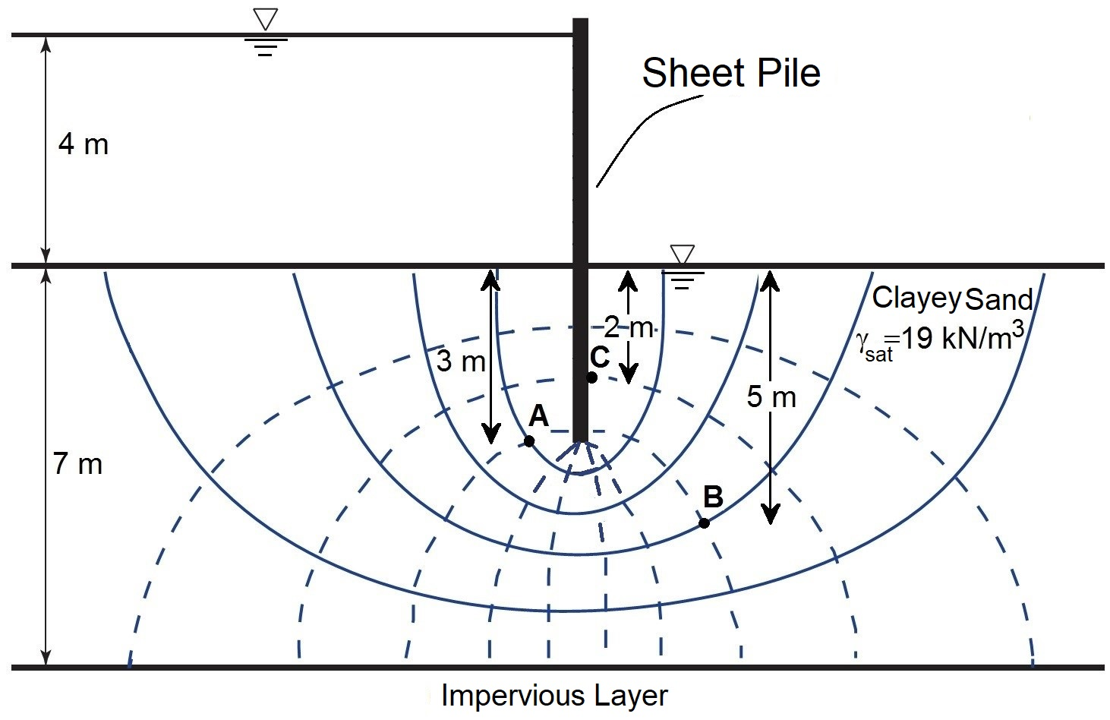
- A building with a raft foundation will be constructed on the ground surface as shown in the figure. Dimensions of the raft foundation is 20 m x 20 m in both direction and the stress that will be due to superstracture load is computed to be q=200 kPa.
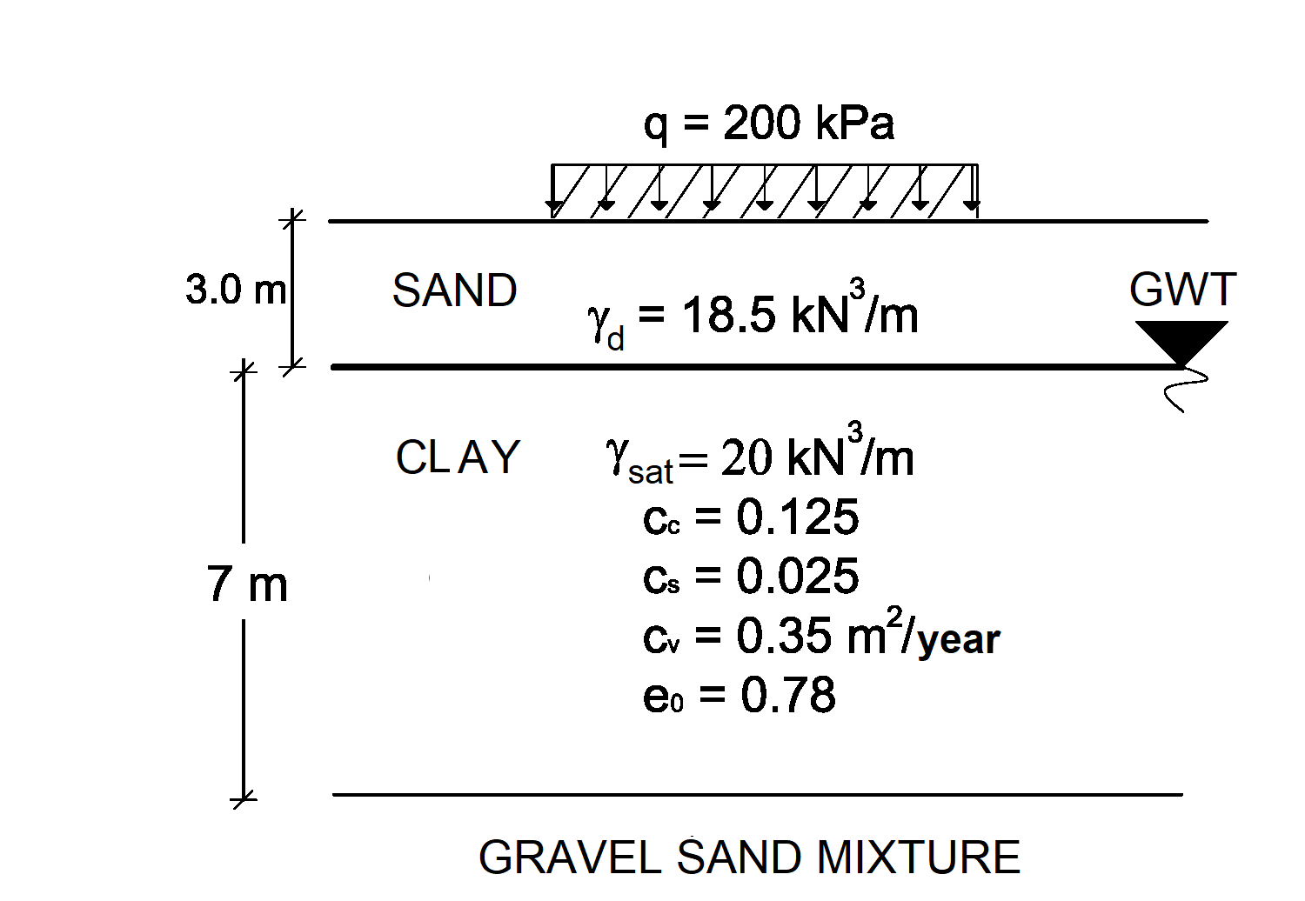
a) Compute the settlement that will take place underneath the center of the raft foundation due to primary consolidation of the normally consolidated clay layer (Determine the pressure increment in the clay layer with simplified method due to uniform loading).
b) Compute the settlement that will take place after 10 years.

U (%) | 10 | 20 | 30 | 40 | 50 | 60 | 70 | 80 | 90
T_{v} | 0.008 | 0.031 | 0.071 | 0.126 | 0.197 | 0.287 | 0.408 | 0.567 | 0.848

- A series of triaxial tests were carried out on undisturbed over consolidated clay samples and the test results are as follows:

Test | Cell Pressure (kPa) | Deviatoric Stress (kPa)
1.CD Test | 120 | 190
2.CD Test | 240 | 360

a) Find the drained shear strength parameters of the clay soil.
b) Compute the angle that failure plane makes with respect to horizontal (α_{f}).
c) Draw the Mohr Circle for the tests and the failure envelope for the clay soil.

Time is 90 minutes. Good Luck…

